A Title is Fewest Possible Words, Accurately Describe the Content
(Center, BoldTimes New Roman 14)

First Author, Second Author, Third Author
Institution/affiliation
addres, telp/fax of institution/affiliation
*Corresponding author, e-mail: xxxx@xxxx.xxx

الملخص
عادي حتى للورقة المكتوبة باللغة الإنجليزية. يجب ان لا يتجاوز الملخص 200 كلمة، Arial 11 يكتب الملخص باللغة العربية وبخط
يجب ان يحتوي الملخص على تقديم بسيط للتعريف بالشغل ثم تحديد المشكلة والنتائج التي تم الحصول عليها.

Abstract
These instructions give you guidelines for preparing papers for Surman journal of science and technology. Use this document as a template if you are using Microsoft Word. Otherwise, use this document as an instruction set. Abstract, with a maximum of 200 words (with spaces), should be self-explanatory and summarize the essential qualities of the paper. The abstract must clearly state the novelty of the work regarding the journal fields. Do not use other characters, like special symbols, Greek alphabet letters, subscript and superscript styles in the abstract. Do not cite references in the abstract.

Keywords: maximum 6 keywords from paper

1. Introduction
The margin text from the left, right, top, and bottom 3 cm. The manuscript is written in Microsoft Word, single space, Times News Roman 12pt and maximum 12 pages, which can be downloaded at the website: http://www.sjst.scst.edu.ly.
The Introduction should provide a clear background, a clear statement of the problem, the relevant literature on the subject, the proposed approach or solution, and the new value of research which it is innovation. It should be understandable to colleagues from a broad range of scientific disciplines.

2. EQUATIONS
The equations should be prepared using "Microsoft Equation" or “MathType” editor. (Insert | Object | Create New | Microsoft Equation or MathType Equation)

3.Tables and Figures
Write the title of the tables above the table with font type Times New Roman 11 blod.
The data inside the table is written with font type Times New Roman 10 bold.

Chemical Analysis of Samples

N | S_{i}O₂ | Fe₂O₃ | Al₂O₃ | CaO | MgO | Na₂O
1 | 90.58 | 90.58 | 90.58 | 90.58 | 90.58 | 90.58
2 | 90.58 | 90.58 | 90.58 | 90.58 | 90.58 | 90.58
3 | 90.58 | 90.58 | 90.58 | 90.58 | 90.58 | 90.58
4 | 90.58 | 90.58 | 90.58 | 90.58 | 90.58 | 90.58
5 | 90.58 | 90.58 | 90.58 | 90.58 | 90.58 | 90.58
6 | 90.58 | 90.58 | 90.58 | 90.58 | 90.58 | 90.58
7 | 90.58 | 90.58 | 90.58 | 90.58 | 90.58 | 90.58
8 | 90.58 | 90.58 | 90.58 | 90.58 | 90.58 | 90.58
9 | 90.58 | 90.58 | 90.58 | 90.58 | 90.58 | 90.58

Figures, drawing, and pictures title should be below them with font size Times New Roman 11 bold

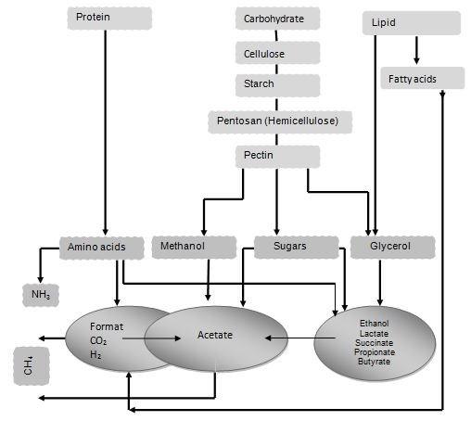

Figure.1 The anaerobic breakdown of biopolymers to give rise to methane

4. Results and Analysis
In this section, it is explained the results of research and at the same time is given the comprehensive discussion. Results can be presented in figures, graphs, tables and others that make the reader understand easily. The discussion can be made in several sub-chapters.

5. Conclusion
The conclusion is intended to help the reader understand why your research should matter to them after they have finished reading the paper. A conclusion is not merely a summary of your points or a re-statement of your research problem but a synthesis of key points.
6. References
The main references are international journals and proceeding. All references should be to the most pertinent and up-to-date sources. References are written in MLA style
Number the citations consecutively, in square brackets [1]. The sentence punctuation follows the brackets [2]. Multiple references [2], [3] are each numbered with separate brackets [1]–[3].
[1] Jiang, Xingliang, et al. "Comparison of DC pollution flashover performances of various types of porcelain, glass, and composite insulators." IEEE Transactions on Power Delivery 23.2 (2008): 1183-1190.
[2] Mehta, Rohit. Objective electrical technology. S. Chand Publishing, 2008.

[3] Gubanski, S. M., Sigbritt Karlsson, and M. A. R. M. Fernando. "Performance of biologically contaminated high voltage insulators." First International Conference on Industrial and Information Systems. IEEE, 2006.
[4] Ault, A., L. Johnson, and Dolah H. Van. "Method of preparing porcelain enamel frit for dry process enameling." U.S. Patent No. 3,836,373. 17 Sep. 1974.

